**Personalized Student Performance**

**Analyzer and recommendation System**

Project Id: 2022-017

Project Status Document

**Hirimuthugoda UJ – IT19138114**

B.Sc. (Hons) in Information Technology specializing in Software Engineering

Department of Software Engineering

Sri Lanka Institute of Information Technology

Sri Lanka

May 2022

**Declaration**

I declare that this is my own work, and this document does not incorporate without acknowledgement any material previously submitted for a degree or diploma in any other university or Institute of higher learning and to the best of our knowledge and belief it does not contain any material previously published or written by another person except where the acknowledgement is made in the text.

IT19138114 - Hirimuthugoda UJ

Table of Contents

1. Microsoft Teams Chats & Meetings 4

2. Microsoft Planner Overall Analysis of Tasks 8

3. Git Lab 10

4. Work Breakdown Structure 11

5. Gantt Chart 12

**Table of Figures**

Figure 1.1 - scheduled meetings 5

Figure 1.2 - team meeting screenshot 5

Figure 1.3 - team meeting screenshot 2 6

Figure 1.4 - team meeting screenshot 3 7

Figure 2.1 - my task chart 1 8

Figure 2.2 - my task chart 2 8

Figure 2.3 - my tasks chart 3 9

Figure 2.4 - my task board 10

Figure 3.1 - git lab commits 10

Figure 4.4.1 - work breakdown structure 11

Figure 5.5.1 - gantt chart 12

## Microsoft Teams Chats & Meetings

Figure 1.1 - scheduled meetings

Figure 1.2 - team meeting screenshot

Figure 1.3 - team meeting screenshot 2

Figure 1.4 - team meeting screenshot 3

## Microsoft Planner Overall Analysis of Tasks

Figure 2.1 - my task chart 1

Figure 2.2 - my task chart 2

Figure 2.3 - my tasks chart 3

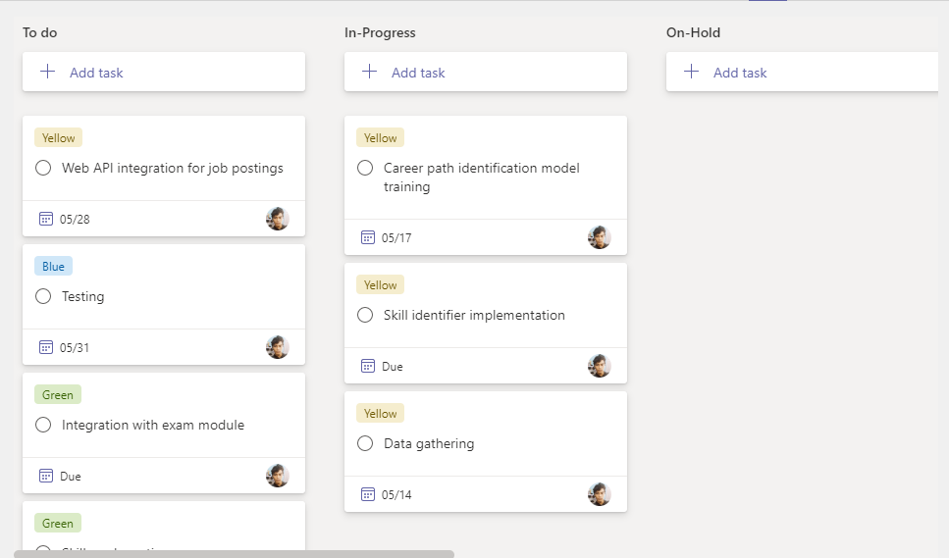

Figure 2.4 - my task board

## Git Lab

Figure 3.1 - git lab commits

## Work Breakdown Structure

Figure 4.4.1 - work breakdown structure

## Gantt Chart

Figure 5.5.1 - gantt chart